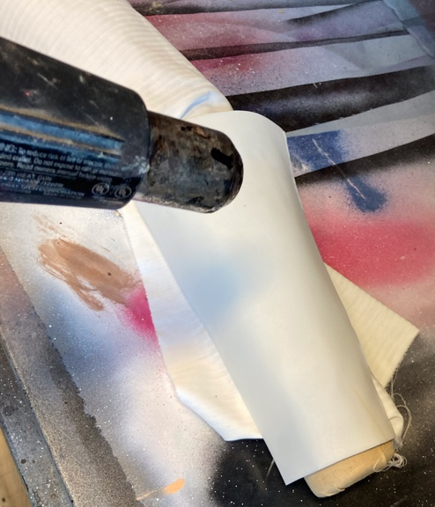
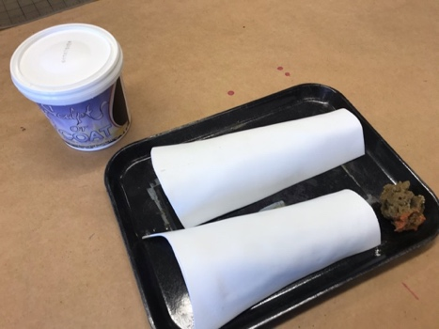
Vambraces:
- I created a pattern bending the kraft paper around my arms.

- First I tried the really bad all black thermoplastics that melted and didn’t shape well.

- Next I cut a Worbla out using the pattern.
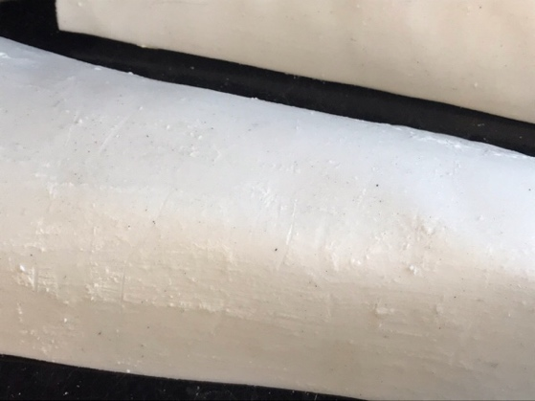
- I then shaped the Worbla over an arm form covered in fabric.
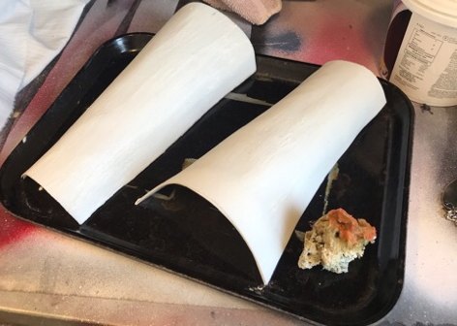
- After the Worbla hardened, I put sculpture coat on it in a streaking sheet like metal manner, and then I used a hard edge to make scoring in it kind of like a knife to simulate dense from where the armor had gotten attacked.

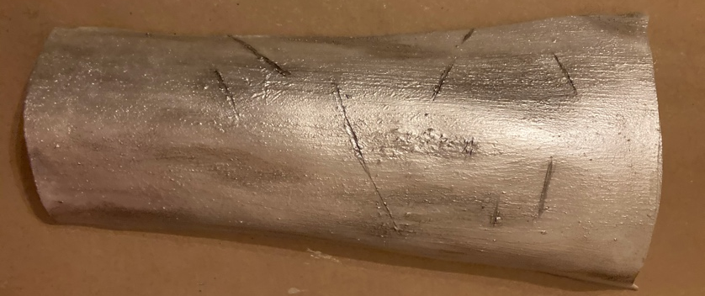
- Next I coated everything in silver acrylic paint. Then I went through in the nicks and scars in the Worbla and used a mixed a darker silver in the textures, and then rubbed it away so that way it would get into the cracks but not sit across the whole surface of the “metal” so that way the textures would read more dramatically

- Next I created holes in the Worbla by heating up an awl with a heat gun. This got the awl incredibly hot and let it slide easily through the Worbla. I created a holes for the hinges and brads.
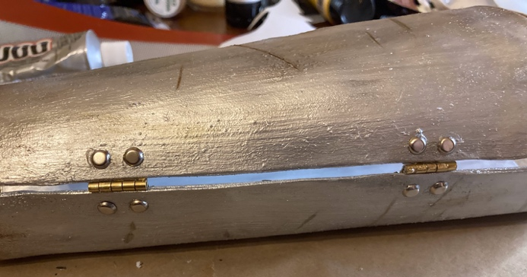
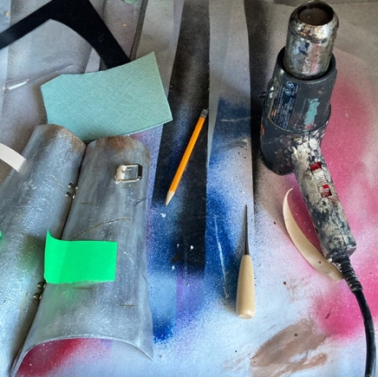
- Next I used the same method as above to create holes for the straps to pull through.

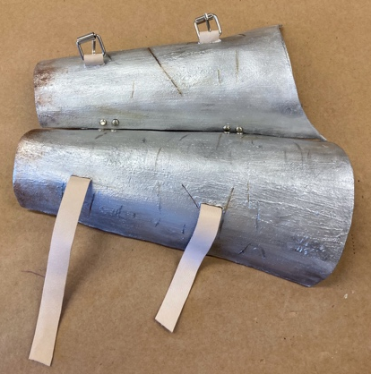
- I then died the leather by taking a dobber of dye and mixing it with a lot of water to create a watered down diet bath and I submerge the leather as quickly as possible removing it and then drying it.

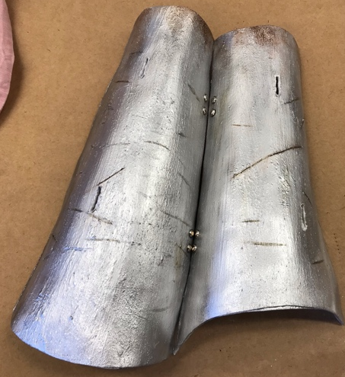
- After the leather was dry, I then conditioned and sealed it so that way we die would not rub off on the other surfaces.

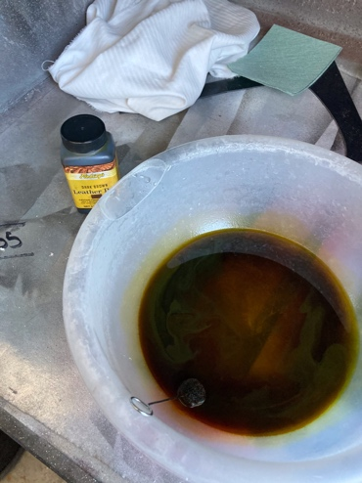
- I then used barge to glue the straps to the interior of the Vambrace. For the barge, I wanted until it felt tacky before pressing them together and then clamping them.

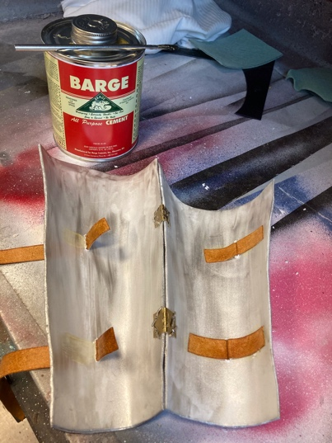
- I then put on the vambrace in order to adjust the straps to the correct length with and without clothing underneath and then I punched holes using a leather punch.

- I then added loops to keep the leather from flapping or pulling out of the buckle.

- I then glued fabric, using E6000, on the inside to protect the brads and leather from getting snagged on other costume pieces and skin.

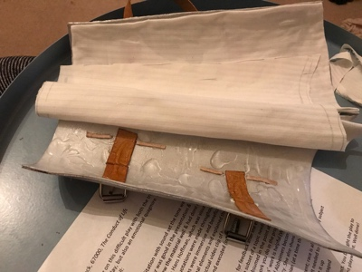
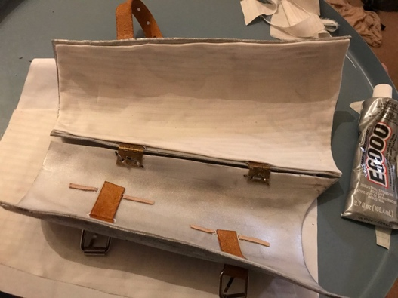
- Last I did touching up painting, specially I painted over the brads, added silver paint into all the holes where white was showing through, and the inside of the vambrace that was white fabric (I would have dyed the fabric first or picked fabric that matched if I was in the costume shop but I was at home and I only had super stretchy fabric in gray/silver).

